Popular Democratic Republic Of Algeria

Ministry Of Higher Education And Scientific Research

University Of Science And Technology Houari Boumediene



Computer ScienceFaculty

Bur & Tic

**Report about Information and Communication Technolgy**

|  |  |  |  |
| --- | --- | --- | --- |
| Firstname | Last name | Matricule | Section /grp |
| sidahmed | salhi | 33232015 | c/87 |

**Report Title:**

Unveiling the Power of ICT: Technologies Transforming Our World

* Introduction: A World Interwoven with Technology

information and Communication Technologies (ICT) have woven themselves into the very fabric of our lives. From instant communication across continents to accessing information at our fingertips, the impact of ICT is undeniable. This report delves into the core components of ICT, explores the leading players in the field (Google and Microsoft), and examines the transformative potential of platforms like Git and GitHub. We will analyze the profound impact of these technologies on diverse aspects of life, from education and healthcare to business and social interaction. Information and Communication Technologies (TIC) encompass a wide range of technologies used to manage and communicate information. This includes hardware, software, networks, and data storage devices. The evolution of TIC has revolutionized the way we work, communicate, and access information, making it an integral part of modern society.

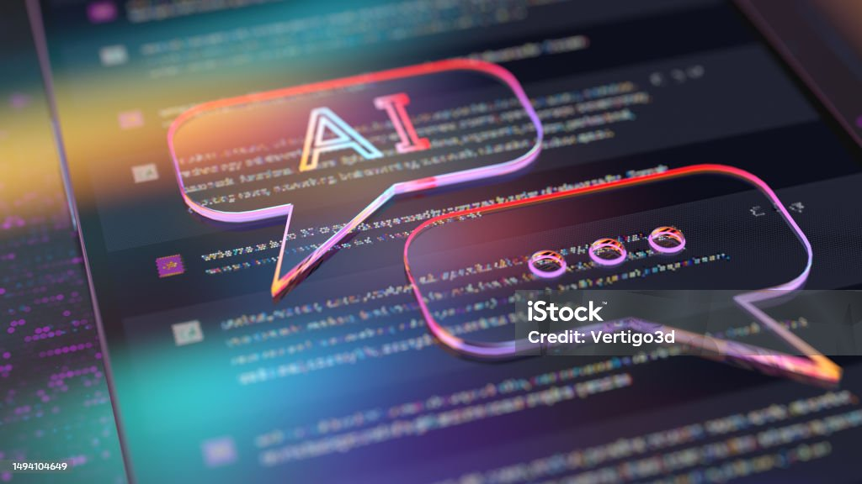

* Understanding ICT: Building Blocks of a Connected World

ICT comprises three key components: Information Technology (IT), Communication Technology, and Networks. IT encompasses hardware and software used to store, process, and manage information, including computers, smartphones, and software applications. Communication Technology facilitates the transmission of data and information through various channels, like telephone lines, fiber optic cables, and wireless networks. Networks, the digital highways, connect these components, enabling information exchange and communication across distances.

1. Information Technology (IT): The Engine of Information Processing

* Hardware: This includes the physical components like computers, laptops, mobile devices, servers, and storage devices. These physical units process, store, and manage information in various forms (data, text, images, audio, video).
* Software: The set of instructions that tells the hardware what to do. Operating systems like Windows, Mac OS, and Android manage core functions, while application software like word processors, web browsers, and productivity tools perform specific tasks.
* Data Management: Systems like databases and data warehouses organize and store vast amounts of information, enabling efficient retrieval and analysis.

2. Communication Technology: Bridging the Gaps

* Networks: The complex infrastructure that facilitates data transmission. Wired networks utilize cables (fiber optic, copper) for high-speed data transfer, while wireless networks employ radio waves for mobile communication (Wi-Fi, cellular).
* Protocols: Standardized sets of rules governing how devices communicate and exchange information. Common protocols include TCP/IP (internet communication), Bluetooth (short-range data transfer), and USB (device connection).
* Communication Channels: The pathways through which information travels. These include telephone lines, cable/satellite connections, fiber optic cables, and wireless spectrum.

3. Convergence: Blending the Lines

The boundaries between IT and Communication Technology are increasingly blurring. Smartphones, for example, combine computer capabilities with phone functions, while cloud computing merges data storage and processing across distributed networks. This convergence fuels innovation and creates new possibilities for information exchange and communication.

Examples of Everyday Applications:

* Communication: Online messaging, video conferencing, social media platforms enable real-time communication across distances.
* Information Access: Search engines, online libraries, and online databases provide access to vast amounts of information instantly.
* Education: Online learning platforms, virtual classrooms, and educational resources revolutionize teaching and learning experiences.
* Business: Cloud computing, collaboration tools, and data analytics empower businesses to operate globally and optimize operations.
* Entertainment: Streaming services, online gaming, and virtual reality experiences offer immersive entertainment options.



* Tech Titans: Google and Microsoft Shaping the Digital Landscape
* Google and Microsoft stand as industry giants, offering a vast array of services and products that have transformed the way we work, learn, and connect.
* Google: Google's suite of suite of services has become an indispensable tool for millions of people around the world. From the ubiquitous search engine to the versatile google docs, Google's products enable us to be more productive and connected. In this section, we’ll explore some of the key features of Google services and examine some of the ways in which they can be used to streamline your workflow.

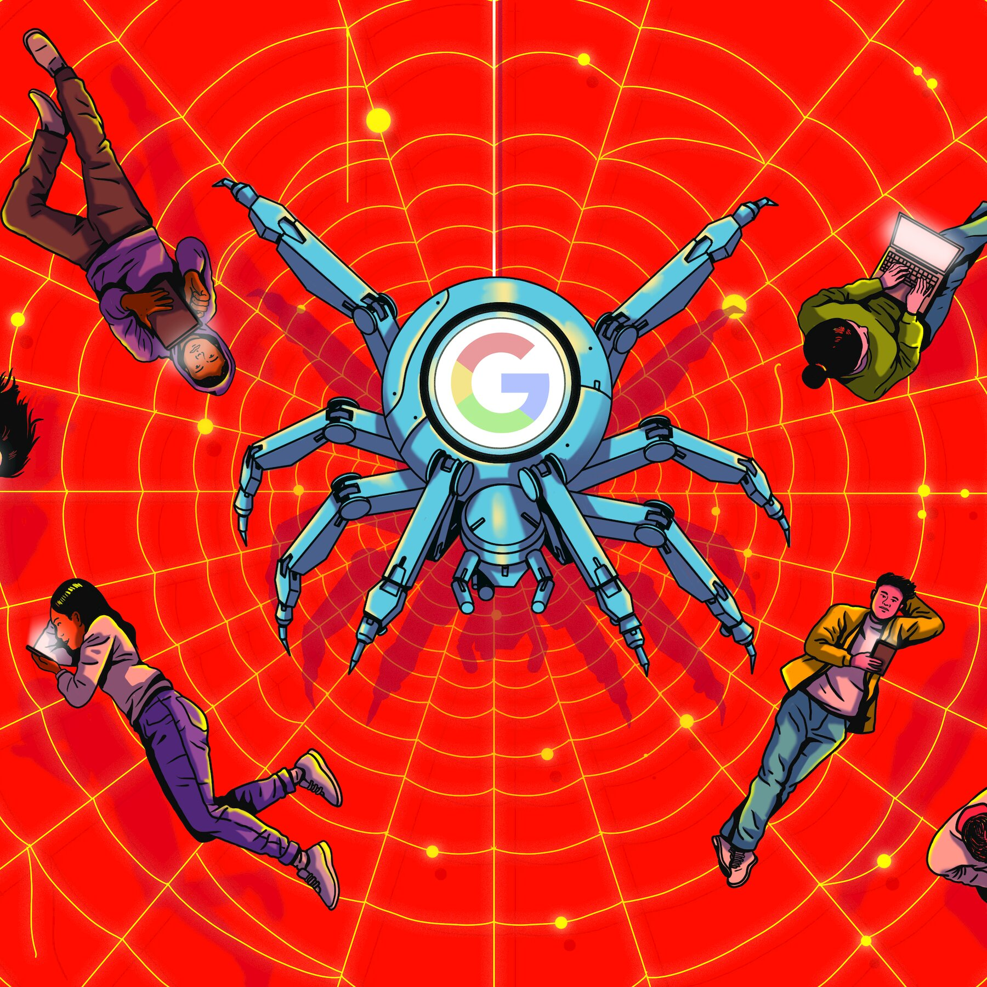

|  |  |
| --- | --- |
| Service: | Functionality: |
| Google search | Find information quickly and easily |
| Gmail | Send and receive emails with ease |
| Google drive | Store and share files with others |
| Google calendar | Organize your schedule and manage events |
| Google docs | Create and edit documents collaboratively |

* Microsoft: Microsoft has been a leader in the tech industry for more than four decades, and their suite of productivity tools has become a staple in offices and households around the world. From the ubiquitous word and excel to the versatile OneNote and outlook, Microsoft's products enable us to be more productive and efficient. In this section, we will explore some of the key features of Microsoft's tools and examine some of the ways in which they can be used to streamline your workflow.

|  |  |
| --- | --- |
| Microsoft word:  Create professional and quality documents with ease. | Microsoft excel:  Manage and analyze data with precision. |
| OneNote:  Organize notes and ideas in a single location. | Outlook:  Manage your emails, calendar and contacts with ease. |



* Open-Source Revolution: Git and GitHub Empowering Collaboration

In the software development world, Git and GitHub have disrupted the traditional closed-source model. Git, a version control system, allows developers to track changes in code, revert to previous versions, and collaborate effectively. GitHub, the world's largest code hosting platform, provides a repository for Git projects, fostering open-source development and collaboration among developers across the globe.

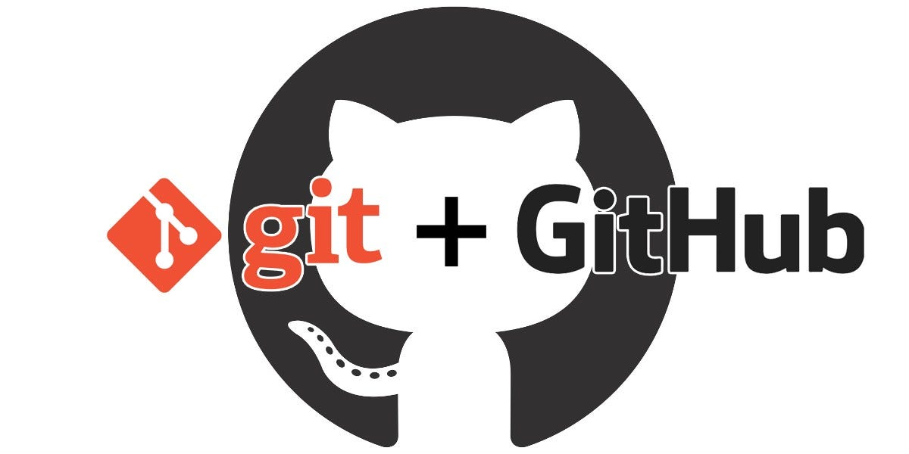

|  |  |
| --- | --- |
| Git: Version Control Made Easier Git simplifies version control by allowing developers to track changes, manage branches, and collaborate on code seamlessly. | GitHub: Empowering Open-Source Collaboration GitHub provides a platform for developers to host, share, and collaborate on code, fostering innovation and open-source development. |

# Impact of Emerging Technologies

|  |  |
| --- | --- |
| AI and Machine Learning | AI and machine learning technologies are revolutionizing data analysis and decision-making processes, enabling automation and predictive insights. |
| IoT | The Internet of Things (IoT) is driving connectivity across various devices, transforming how data is collected, analyzed, and utilized in diverse environments. |
| Blockchain | Blockchain technology introduces secure and transparent transaction processes, impacting industries from finance to supply chain management. |

The impact of ICT extends far beyond convenience and connectivity. It has revolutionized:

* Education: Online learning platforms and educational resources have democratized access to knowledge and created personalized learning experiences.
* Healthcare: Telemedicine, electronic health records, and medical technologies have improved healthcare delivery and patient outcomes.
* Business: Cloud computing, communication tools, and data analytics have empowered businesses to operate globally, optimize operations, and gain valuable insights.
* Social Interaction: Social media platforms and communication tools have connected people across borders and fostered collaboration across diverse communities.
* However, the rise of ICT also presents challenges:
* Digital Divide: Unequal access to technology can exacerbate existing socioeconomic inequalities.
* Data Privacy and Security: Concerns about data collection, surveillance, and cyber threats raise ethical considerations.
* Job displacement: Automation and AI advancements may lead to job losses in certain sectors.

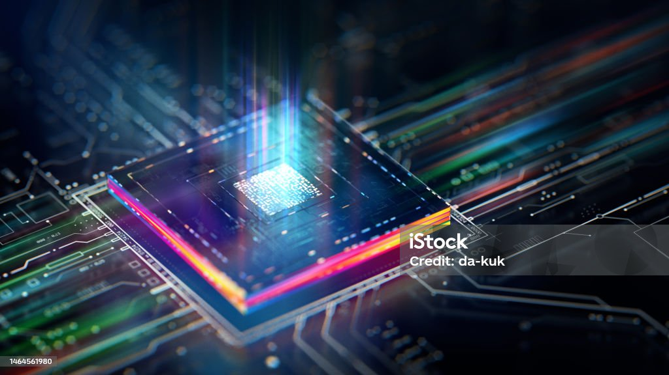

* Navigating the Evolving Landscape: Challenges and Opportunities

1. As ICT continues to evolve, we must adapt and address the challenges it presents while capitalizing on its immense potential:
2. Bridging the Digital Divide: Initiatives that provide affordable internet access and digital literacy training are crucial to ensure equitable participation in the digital world.
3. Protecting Privacy and Security: Robust data protection laws and ethical development practices are essential to safeguard user privacy and combat cyber threats.
4. Preparing for the Future of Work: Upskilling and reskilling initiatives are necessary to equip individuals with the skills needed to thrive in the changing job market.

* The Future of ICT: Emerging Trends and Unforeseen Horizons

1. AI Ascending: AI is on track to reshape industries, from healthcare with personalized medicine to autonomous vehicles in transportation. Ethical considerations like bias and job displacement require careful navigation.
2. Data Deluge Decoded: Big data and advanced analytics will unlock valuable insights, shaping business decisions, scientific research, and even smart cities. Security and privacy remain crucial challenges.
3. Interconnected Everything: The Internet of Things (IoT) will weave a web of "smart" devices, optimizing resources and personalizing experiences. Securing these connected devices is paramount.
4. Quantum Leap: Quantum computing promises game-changing speed for complex problems, impacting drug discovery and cryptography. Expect exciting advances but remember it's still in its early stages.
5. Beyond Screens: Human-computer interaction is evolving with VR, AR, and brain-computer interfaces. The impact on privacy, mental health, and our very identity demands thoughtful exploration.
6. Uncharted Horizons: The future holds unforeseen surprises. Stay curious, explore emerging trends, and actively shape a responsible and sustainable future for technology.

# Conclusion: Embracing the TIC Revolution

In this report, we embarked on a journey through the vast landscape of TIC and its related technologies. We explored the powerful offerings of Google services and Microsoft tools, delved into the world of Git and GitHub, and witnessed the wide-ranging impact of TIC on businesses and society. As TIC continues to evolve, it is crucial to embrace its potential, adapt to technological advancements, and leverage its power to forge a digital future that benefits all.

#### Harnessing Technological Potential

By embracing TIC, organizations and individuals can unlock the vast potential of technology to achieve their goals.

#### Driving Innovation and Collaboration

TIC fosters innovation and collaboration, empowering individuals and businesses to create, connect, and thrive.

#### A Digital Future for All

As TIC shapes our world, it is crucial to ensure its benefits are accessible and inclusive for everyone.